|  |  |
| --- | --- |
| **Dust Bowl Migrants** Evidence.png  **Using Evidence** | |
| **Objective** | *What were the effects of the Dust Bowl ? How did the Dust Bowl impact and shape migration patterns? Who were the Dust Bowl migrants?* |

**Contextualization - Part 1:** Read the historical context provided below and closely review the map. When you are done, answer the contextualization questions on the next page.

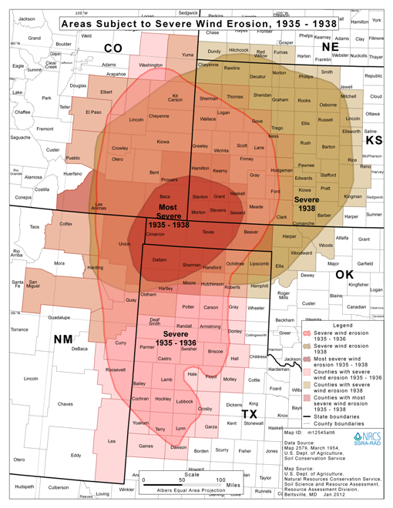

The Dust Bowl began as a drought, or severe lack of rain water. When the drought struck in 1930, temperatures soared. For example, in 1930 it was 108 degrees in Kansas for weeks on end. As the drought waged on, high winds would blow the top layer of soil away, eroding the land and making it impossible to farm. One Kansas county, which produced 3.4 million bushels of wheat in 1931, harvested just 89,000 bushels in 1933. Regular rainfall would not return to the region until 1939.

The Dust Bowl resulted in hundreds of families migrating to the southwest and West Coast. Although the Dust Bowl included many Great Plains states, the migrants were generically known as "Okies," referring to the approximately 20 percent who were from Oklahoma. The migrants came primarily from Oklahoma, Texas, Arkansas, and Missouri. Most migrants ended up in California.

California was not the promised land of the migrants' dreams. Although the weather was comparatively better and farmers' fields were bountiful with produce, Californians also felt the effects of the Depression. Local and state infrastructures were already overburdened, and the steady stream of newly arriving migrants was more than the system could bear. Additionally, arrival in California did not put an end to the migrants' travels. Their lives were characterized by migration. In an attempt to maintain a steady income, workers had to follow the harvest around the state. When potatoes were ready to be picked, the migrants needed to be where the potatoes were. The same principle applied to harvesting cotton, lemons, oranges, peas, and other crops.

Source for map: [National Resources Conservation Service](https://www.nrcs.usda.gov/wps/portal/nrcs/detail/national/about/history/?cid=stelprdb1049437) | Source for text: [Digital History](http://www.digitalhistory.uh.edu/disp_textbook.cfm?smtID=2&psid=3441), [Library of Congress](https://www.loc.gov/collections/todd-and-sonkin-migrant-workers-from-1940-to-1941/)

**Contextualization - Part 1 - Analysis Questions:**

1. How did the weather phenomenon during the Dust Bowl impact farming? __________________________________________

____________________________________________________________________________________________________________

____________________________________________________________________________________________________________

1. When did the Dust Bowl take place in relation to the Great Depression? ___________________________________________

____________________________________________________________________________________________________________

____________________________________________________________________________________________________________

1. Who were the “okies”? Do you think that nickname was a positive or negative name? Why or why not? _______________

____________________________________________________________________________________________________________

____________________________________________________________________________________________________________

1. Where did most Dust Bowl migrants end up? ___________________________________________________________________

____________________________________________________________________________________________________________

1. According to the map, which many states were impacted by the Dust Bowl ? _______________________________________

____________________________________________________________________________________________________________

**Contextualization - part 2:** Review the following images of Dust Bowl migrants. Read the captions and answer the analysis questions that follow on the back. When you are done, reflect on your image with two different partners:

* first reflect with a partner who had the same image as you, compare your answers to your image analysis questions
* secondly, reflect with a partner who had a different image as you, compare your answers to your image analysis questions

Use the questions below to shape your paired reflection.

**Same Image Reflection:** What does your image tell you about Dust Bowl migrants?

____________________________________________________________________________________________________________

____________________________________________________________________________________________________________

____________________________________________________________________________________________________________

____________________________________________________________________________________________________________

**Different Image Reflection:** What does this new image change, add, or confirm to you about Dust Bowl migrants?

____________________________________________________________________________________________________________

____________________________________________________________________________________________________________

____________________________________________________________________________________________________________

____________________________________________________________________________________________________________

**Image 1**

Caption: Example of self-resettlement in California. Oklahoma farm family on highway between Blythe and Indio. Forced by the drought of 1936 to abandon their farm, they set out with their children to drive to California. Picking cotton in Arizona for a day or two at a time gave them enough for food and gas to continue. On this day, they were within a day's travel of their destination, Bakersfield, California. Their car had broken down en route and was abandoned. 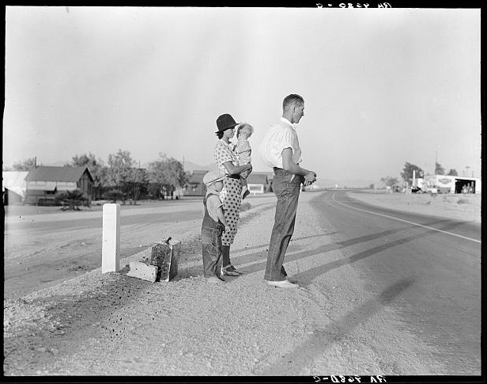

Photographer: Dorothea Lange

Date: August 1936

Original Image: [Library of Congress](http://www.loc.gov/pictures/item/2017763106/)

**Image 1 - Analysis Questions**

1. List all the things you see in this image.

____________________________________________________________________________________________________________

____________________________________________________________________________________________________________

____________________________________________________________________________________________________________

1. Is this image happy or sad? What makes you say that (include / circle two specific details from the image to support your claims)?

____________________________________________________________________________________________________________

____________________________________________________________________________________________________________

____________________________________________________________________________________________________________

1. Give a new title to this image. Star the details of the picture that led you to the new title. Why did you choose that title?

____________________________________________________________________________________________________________

____________________________________________________________________________________________________________

____________________________________________________________________________________________________________

1. What is the most important part of this picture? What makes you say that?

____________________________________________________________________________________________________________

____________________________________________________________________________________________________________

____________________________________________________________________________________________________________

**Image 2**

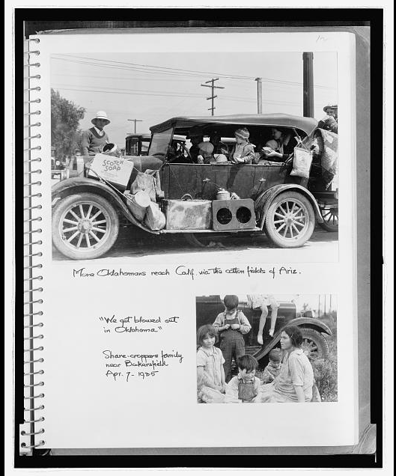

## Captions: More Oklahomans reach Calif. via the cotton fields of Ariz. ; "We got blowed out in Oklahoma." Share-croppers family near Bakersfield.

Photographer: Dorothea Lange

Date: April 7th 1935

Original Image: [Library of Congress](https://www.loc.gov/item/2007683524/)

**Image 2 - Analysis Questions**

1. List all the things you see in this image.

____________________________________________________________________________________________________________

____________________________________________________________________________________________________________

____________________________________________________________________________________________________________

1. Is this image happy or sad? What makes you say that (include / circle two specific details from the image to support your claims)?

____________________________________________________________________________________________________________

____________________________________________________________________________________________________________

____________________________________________________________________________________________________________

1. Give a new title to this image. Star the details of the picture that led you to the new title. Why did you choose that title?

____________________________________________________________________________________________________________

____________________________________________________________________________________________________________

____________________________________________________________________________________________________________

1. What is the most important part of this picture? What makes you say that?

____________________________________________________________________________________________________________

____________________________________________________________________________________________________________

____________________________________________________________________________________________________________

**Image 3**

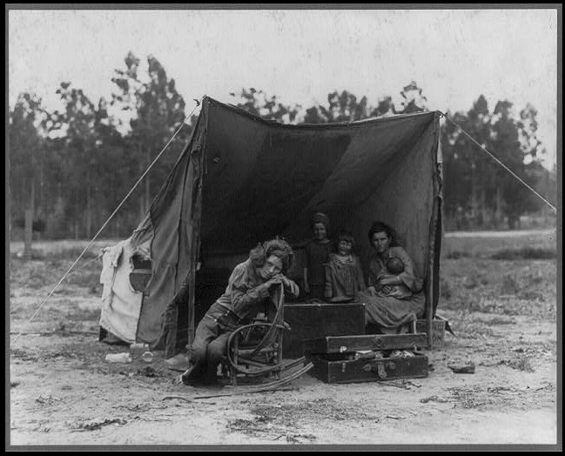

## Caption: Migrant agricultural worker's family. Seven hungry children. Mother aged thirty-two. Father is native Californian. Taken in: Nipomo, California

Photographer: Dorothea Lange

Date: February or March 1936

Original Image: [Library of Congress](https://www.loc.gov/pictures/item/2017762908/)

**Image 3 - Analysis Questions**

1. List all the things you see in this image.

____________________________________________________________________________________________________________

____________________________________________________________________________________________________________

____________________________________________________________________________________________________________

1. Is this image happy or sad? What makes you say that (include / circle two specific details from the image to support your claims)?

____________________________________________________________________________________________________________

____________________________________________________________________________________________________________

____________________________________________________________________________________________________________

1. Give a new title to this image. Star the details of the picture that led you to the new title. Why did you choose that title?

____________________________________________________________________________________________________________

____________________________________________________________________________________________________________

____________________________________________________________________________________________________________

1. What is the most important part of this picture? What makes you say that?

____________________________________________________________________________________________________________

____________________________________________________________________________________________________________

____________________________________________________________________________________________________________

**Image 4**

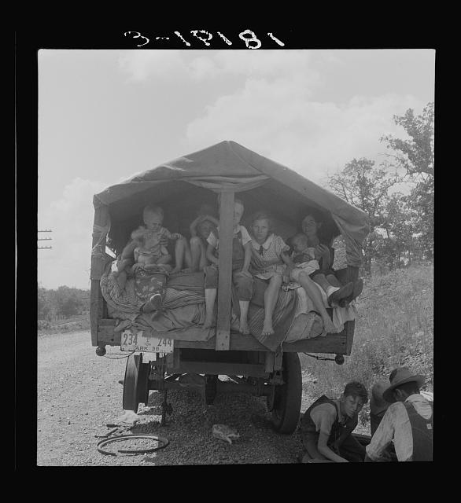

Caption: On highway no. 1 of the "OK" state near Webbers Falls, Muskogee County, Oklahoma. Seven children and eldest son's family. Father was a blacksmith in Paris, Arkansas. Son was a tenant farmer. "We're bound for Kingfisher (Oklahoma wheat) and Lubbock (Texas cotton). We're not trying to but we'll be in California yet. We're not going back to Arkansas; believe I can better myself"

Photographer: Dorothea Lange

Date: June 1938

Original Image: [Library of Congress](https://www.loc.gov/item/2017770570/)

**Image 4 - Analysis Questions**

1. List all the things you see in this image.

____________________________________________________________________________________________________________

____________________________________________________________________________________________________________

____________________________________________________________________________________________________________

1. Is this image happy or sad? What makes you say that (include / circle two specific details from the image to support your claims)?

____________________________________________________________________________________________________________

____________________________________________________________________________________________________________

____________________________________________________________________________________________________________

1. Give a new title to this image. Star the details of the picture that led you to the new title. Why did you choose that title?

____________________________________________________________________________________________________________

____________________________________________________________________________________________________________

____________________________________________________________________________________________________________

1. What is the most important part of this picture? What makes you say that?

____________________________________________________________________________________________________________

____________________________________________________________________________________________________________

____________________________________________________________________________________________________________

**Primary Source Document Analysis**

***Directions:*** You have been assigned to read either anexcerpt of John Steinbeck’s ***Harvest Gypsies*** or ***Starvation Under the Orange Trees*** (note: in both readings the bolded words are defined below the reading).

* Read the excerpt and answer the analysis questions that follow.
* When you are done, find a partner who read the opposite primary source from you and share what you learned about the Dust Bowl and Dust Bowl migrants with each other.
* When you are done sharing, answer the reflection question below together.

Compare and contrast the images of the Dust Bowl migrants with the descriptions of Dust Bowl migrants presented in the texts. How does the description of the Dust Bowl migrants in the primary source texts alter, change, or confirm what you knew about the Dust Bowl migrants after reviewing the image(s) above?

____________________________________________________________________________________________________________

____________________________________________________________________________________________________________

____________________________________________________________________________________________________________

____________________________________________________________________________________________________________

____________________________________________________________________________________________________________

____________________________________________________________________________________________________________

**Primary Source Document Analysis - Harvest Gypsies by John Steinbeck**

|  |  |  |
| --- | --- | --- |
| Thus, in California we find a curious attitude toward a group that makes our **agriculture** successful. The **migrants** are needed, and they are hated. Arriving in a district they find the dislike always **meted** out by the resident to the foreigner, the outlander. This hatred of the stranger occurs in the whole range of human history, from the most **primitive** village form to our own highly organized industrial farming. The migrants are hated for the following reasons, that they are ignorant and dirty people, that they are carriers of disease, that they increase the necessity for police and the tax bill for schooling in a community, and that if they are allowed to organize they can, simply by refusing to work, wipe out the season's crops. They are never received into a community nor into the life of a community. Wanderers in fact, they are never allowed to feel at home in the communities that demand their services.  Let us see what kind of people they are, where they come from, and the routes of their wanderings. In the past they have been of several races, encouraged to come and often imported as cheap labor; Chinese in the early period, then Filipinos, Japanese and Mexicans. These were foreigners, and as such they were **ostracized** and segregated and herded about.  If they attempted to organize they were deported or arrested, and having no **advocates** they were never able to get a hearing for their problems. But in recent years the foreign migrants have begun to organize, and at this danger signal they have been deported in great numbers, for there was a new **reservoir** from which a great quantity of cheap labor could be obtained.  The drought in the middle west has driven the agricultural populations of Oklahoma, Nebraska and parts of Kansas and Texas westward. Their lands are destroyed and they can never go back to them. Thousands of them are crossing the borders in ancient rattling automobiles, **destitute** and hungry and homeless, ready to accept any pay so that they may eat and feed their children. And this is a new thing in migrant labor, for the foreign workers were usually imported without their children and everything that remains of their old life with them.  The migrants arrive in California usually having used up every resource to get here, even to the selling of the poor blankets and utensils and tools on the way to buy gasoline. They arrive **bewildered** and beaten and usually in a state of semi-starvation, with only one necessity to face immediately, and that is to find work at any wage in order that the family may eat.  And there is only one field in California that can receive them. Ineligible for relief, they must become migratory field workers.  The earlier foreign migrants have invariably been drawn from a **peon** class. This is not the case with the new migrants.They are small farmers who have lost their farms, or farm hands who have lived with the family in the old American way. They are men who have worked hard on their own farms and have felt the pride of possessing and living in close touch with the land. They are resourceful and intelligent Americans who have gone through the hell of the drought, have seen their lands wither and die and the topsoil blow away; and this, to a man who has owned his land, is a curious and terrible pain.  And there is another difference between their old life and the new. They have come from the little farm districts where democracy was not only possible but unavoidable, where popular government, whether practiced in the **Grange**, in church organization or in local government, was the responsibility of every man. And they have come into the country where, because of the movement necessary to make a living, they are not allowed any vote whatever, but are rather considered a properly unprivileged class.  As one little boy in a **squatters** camp said, "When they need us they call us migrants, and when we've picked their crop, we're bums and we got to get out."  **Vocabulary**   |  |  | | --- | --- | | Agriculture - science and practice of farming  Migrants - someone who moves from place to place doing seasonal work  Meted - dispense or hand out justice or punishment  Primitive - not developed, simple  Ostracized - exclude someone from a group, freeze out  Advocates - someone who supports or recommends something | Reservoir - supply  Destitute - without basic necessities, poor, penniless  Bewildered - cause someone to be confused or frightened  Peon - unskilled farm worker, lower class, day laborer  Grange - farm or countryside, rural land  Squatters - person who unlawfully occupies a land or building | |

Source: ***The Harvest Gypsies*** was originally published in seven parts the *San Francisco News*, between October 5 and October 12, 1936. This excerpt comes from Eric Foner’s *Voices of Freedom - Volume 2.*

**Harvest Gypsies - Analysis Questions:**

1. *Close Reading:* According to Steinbeck, why are migrants always hated? ___________________________________________________

_____________________________________________________________________________________________________________________

_____________________________________________________________________________________________________________________

1. *Close Reading:* In the past, where did the migrants come from? How were they treated? _____________________________________

_____________________________________________________________________________________________________________________

_____________________________________________________________________________________________________________________

1. *Analysis:* How would you describe the *new migrants (Dust Bowl migrants)*, based on your reading of this primary source?

_____________________________________________________________________________________________________________________

_____________________________________________________________________________________________________________________

1. *Analysis:* What does the little boy in the squatter’s camp mean when he says: *“When they need us they call us migrants, and when we've picked their crop, we're bums and we got to get out."* What does that tell you about how the Dust Bowl migrants are viewed by others?

_____________________________________________________________________________________________________________________

_____________________________________________________________________________________________________________________

_____________________________________________________________________________________________________________________

1. *Analysis:* Why do you think Steinbeck called this essay “Harvest Gypsies”?

____________________________________________________________________________________________________________________

_____________________________________________________________________________________________________________________

_____________________________________________________________________________________________________________________

**Primary Source Document Analysis - Starvation under the Orange Trees by John Steinbeck**

|  |  |  |  |  |  |
| --- | --- | --- | --- | --- | --- |
| The Spring is rich and green in California this year. In the fields the wild grass is ten inches high, and in the orchards and vineyards the grass is deep and nearly ready to be plowed under to **enrich** the soil. Already the flowers are starting to bloom. Very shortly one of the oil companies will be broadcasting the locations of the wild-flower masses. It is a beautiful spring. There has been no war in California, no plague, no bombing of open towns and roads, no shelling of cities. It is a beautiful year. And thousands of families are starving in California. In the county seats the **coroners** are filling in "malnutrition" in the spaces left for "causes of death." For some reason, a coroner shrinks from writing "starvation" when a thin child is dead in a tent.  For it's in the tents you see along the roads and in the shacks built from dump heap material that the hunger is, and it isn't malnutrition. It is starvation. Malnutrition means you go without certain food essentials and take a long time to die, but starvation means no food at all. The green grass spreading right into the tent doorways and the orange trees are loaded. In the cotton fields, a few wisps of the old crop cling to the black stems.  But the people who picked the cotton, and cut the peaches and apricots, who crawled all day in the rows of lettuce and beans are hungry. The men who harvested the crops of California, the women and girls who stood all day and half the night in the canneries, are starving. It was so two years ago in Nipomo, it is so now, it will continue to be so until the rich produce of California can be grown and harvested on some other basis than that of stupidity and greed.  What is to be done about it? The Federal Government is trying to feed and give direct relief through the *New Deal*, but it is difficult to do quickly for there are forms to fill out, questions to ask, for fear someone who isn't actually starving may get something. The state relief organizations are trying to send those who haven't been in the state for a year back to the states they came from… With the exception of a little pea picking, there isn't going to be any work for nearly three months.  There is sickness in the tents, pneumonia and measles, tuberculosis. Measles in a tent, with no way to protect the eyes, means a child with weakened eyes for life. And there are varied diseases attributable to hunger, **rickets** and the beginning of **pellagra**. The nurses in the county, and there aren't one-tenth enough of them, are working their heads off, doing a magnificent job and they can only begin to do the work. The corps includes nurses assigned by the federal and state public health services, school nurses and county health nurses, and a few nurses furnished by the Council of Women for Home Missions, a national church organization. I've seen them, red-eyed, weary from far too many hours...  ...It may be of interest to **reiterate** the reasons why these people are in the state and the reason they must go hungry. They are here because we need them. Before the white American migrants were here, it was the custom in California to import great numbers of Mexicans, Filipinos, Japanese, to keep them segregated, to herd them about like animals, and, if there were any complaints, to deport or to imprison the leaders. This system of labor was a dream of heaven to such employers as those who now fear foreign agitators so much.  But then the dust and the tractors began displacing the sharecroppers of Oklahoma, Texas, Kansas and Arkansas. Families who had lived for many years on the little "cropper lands" were **dispossessed** because the land was in the hands of the banks and finance companies, and because these owners found that one man with a tractor could do the work of ten sharecropper families. Faced with the question of starving or moving, these dispossessed families came west. To a certain extent they were **actuated** by advertisements and hand bills distributed by labor contractors from California. It is to the advantage of the corporate farmer to have too much labor, for then wages can be cut. Then people who are hungry will fight each other for a job rather than the employer for a **living wage**.  It is possible to make money for food and gasoline for at least nine months of the year if you are quick on the get away, if your wife and children work in the fields. But then the dead three months strikes, and what can you do then? The migrant cannot save anything. It takes everything he can make to feed his family and buy gasoline to go to the next job. If you don't believe this, go out in the cotton fields next year. Work all day and see if you have made thirty-five cents. A good picker makes more, of course, but you can't.  The method of concentrating labor for one of the great crops is this. **Handbills** are distributed, advertisements are printed. You've seen them. Cotton pickers wanted in Bakersfield or Fresno or Imperial Valley. Then all the available migrants rush to the scene. They arrive with no money and little food. The reserve has been spent getting there. If wages happen to drop a little, they must take them any way. The moment the crop is picked, the locals begin to try to get rid of the people who have harvested their crops. They want to run them out, move them on.  ….About the fifteenth of January the dead time sets in. There is no work. First the gasoline gives out. And without gasoline a man cannot go to a job even if he could get one. Then the food goes. And then in the rains, with insufficient food, the children develop colds because the ground in the tents is wet. I talked to a man last week who lost two children in ten days with pneumonia. His face was hard and fierce and he didn't talk much. I talked to a girl with a baby and offered her a cigarette. She took two puffs and vomited in the street. She was ashamed. She shouldn't have tried to smoke, she said, for she hadn't eaten for two days.  I heard a man whimpering that the baby was sucking but nothing came out of the breast. I heard a man explain very shyly that his little girl couldn't go to school because she was too weak to walk to school and besides the school lunches of the other children made her unhappy.  I heard a man tell in a **monotone** how he couldn't get a doctor while his oldest boy died of pneumonia but that a doctor came right away after it was dead. It is easy to get a doctor to look at a corpse, not so easy to get one for a live person. It is easy to get a body buried. A truck comes right out and takes it away. The state is much more interested in how you die than in how you live. The man who was telling about it had just found that out. He didn't want to believe it. Next year the hunger will come again and the year after that and so on until we come out of this coma and realize that our agriculture for all its great produce is a failure.  If you buy a farm horse and only feed him when you work him, the horse will die. No one complains of the necessity of feeding the horse when he is not working. But we complain about feeding the men and women who work our lands. Is it possible that this state is so stupid, so vicious and so greedy that it cannot feed and clothe the men and women who help to make it the richest area in the world? Must the hunger become anger and the anger fury before anything will be done?  **Vocabulary**   |  |  |  |  |  | | --- | --- | --- | --- | --- | | Enrich - improve or enhance the quality  Coroners - an official who investigates death | Rickets - disease of children caused by Vitamin D deficiency  Pellagra - Deficiency disease, leads to diarrhea, mental disturbance, usually caused by eating too much corn | Reiterate - repeat  Dispossessed - deprived of land, or other possessions, robbed, cheated of ownership | Actuated - cause of something occurring  Living Wage - minimum pay needed to live comfortably | Handbills - small printed advertisements, brochure  Monotone - unchanging pitch or tone in voice | |

Source: [Starvation Under the Orange Trees, excerpted](http://newdeal.feri.org/steinbeck/steinbeck01.htm) - originally published in the Monterey Trader, April 15th 1938

**Starvation Under the Orange Trees - Analysis Questions:**

1. *Analysis:* What is the difference between malnutrition and starvation?_______________________________________________________

_____________________________________________________________________________________________________________________

_____________________________________________________________________________________________________________________

1. *Close Reading:* What diseases are spreading amongst the migrant farmers? How might this impact their already poor health due to starvation? __________________________________________________________________________________________________________

_____________________________________________________________________________________________________________________

_____________________________________________________________________________________________________________________

1. *Close Reading:* According to Steinbeck, how helpful have the New Deal relief programs been?_________________________________

_____________________________________________________________________________________________________________________

_____________________________________________________________________________________________________________________

1. *Analysis:* What does “....the state is much more interested in how you die than in how you live” mean? What does it mean for American citizens?

_____________________________________________________________________________________________________________________

_____________________________________________________________________________________________________________________

_____________________________________________________________________________________________________________________

1. *Analysis:* What does Steinbeck mean when he writes: “*If you buy a farm horse and only feed him when you work him, the horse will die. No one complains of the necessity of feeding the horse when he is not working. But we complain about feeding the men and women who work our lands. Is it possible that this state is so stupid, so vicious and so greedy that it cannot feed and clothe the men and women who help to make it the richest area in the world? Must the hunger become anger and the anger fury before anything will be done?*”

_____________________________________________________________________________________________________________________

_____________________________________________________________________________________________________________________

_____________________________________________________________________________________________________________________

_____________________________________________________________________________________________________________________

_____________________________________________________________________________________________________________________

_____________________________________________________________________________________________________________________

|  |  |
| --- | --- |
| **Dust Bowl Migrants** Evidence.png  **Using Evidence** | |
| **Written Task** | *What were the effects of the Dust Bowl ? How did the Dust Bowl impact and shape migration patterns? Who were the Dust Bowl migrants?* |

**Directions:** Using information from the documents above, please respond to the following task.

**Task:** Using the information from the documents above and your knowledge of US History to respond to the following task:

|  |
| --- |
| Using the evidence you gathered from the primary sources above, develop a script for a dialogue or conversation between President Franklin D. Roosevelt and a Dust Bowl migrant farmer. The script should have two characters - FDR and the Dust Bowl migrant farmer.     * The dialogue or conversation should highlight why the farmer is migrating from the Midwest to California, and what he or she found when he or she arrived in California * What the farmer thinks the government needs to do for farmers who were left poor and penniless as a result of the Dust Bowl   Use the documents above to support your creation of the script   * Underline at least three pieces of evidence from the primary sources above within your script   *Your script should be at least 1.5 pages long* |